**Experiment No:09**

**Experiment Name:**Priority Scheduling Algorithm Implementation.

**Aim and Objectives:** To Learn what is PriorityScheduling algorithm and how it work.

**Priority scheduling Algorithm:**

In priority scheduling algorithm each process has a priority associated with it and as each process hits the queue, it is stored in based on its priority so that process with higher priority are dealt with first. It should be noted that equal priority processes are scheduled in FCFS order.

**Source Code:**

#include<stdio.h>

int main()

{

int bt[20],p[20],wt[20],tat[20],pr[20],i,j,n,total=0,pos,temp,avg_wt,avg_tat;

printf("Enter Total Number of Process:");

scanf("%d",&n);

printf("\nEnter Burst Time and Priority\n");

for(i=0;i<n;i++)

{

printf("\nP[%d]\n",i+1);

printf("Burst Time:");

scanf("%d",&bt[i]);

printf("Priority:");

scanf("%d",&pr[i]);

p[i]=i+1;

}

for(i=0;i<n;i++)

{

pos=i;

for(j=i+1;j<n;j++)

{

if(pr[j]<pr[pos])

pos=j;

}

temp=pr[i];

pr[i]=pr[pos];

pr[pos]=temp;

temp=bt[i];

bt[i]=bt[pos];

bt[pos]=temp;

temp=p[i];

p[i]=p[pos];

p[pos]=temp;

}

wt[0]=0;

//calculate waiting time

for(i=1;i<n;i++)

{

wt[i]=0;

for(j=0;j<i;j++)

wt[i]+=bt[j];

total+=wt[i];

}

avg_wt=total/n;

total=0;

printf("\nProcess\t Burst Time \tWaiting Time\tTurnaround Time");

for(i=0;i<n;i++)

{

tat[i]=bt[i]+wt[i];

total+=tat[i];

printf("\nP[%d]\t\t %d\t\t %d\t\t\t%d",p[i],bt[i],wt[i],tat[i]);

}

avg_tat=total/n; //average turnaround time

printf("\n\nAverage Waiting Time=%d",avg_wt);

printf("\nAverage Turnaround Time=%d\n",avg_tat);

return 0;

}

**Output:**

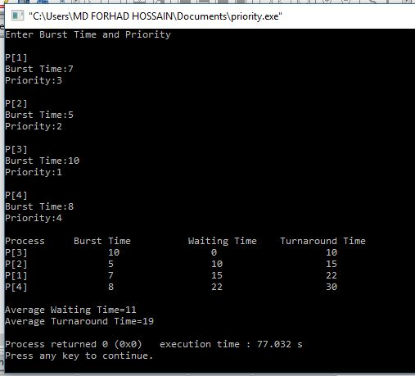

**Discussion:**

After doing this labreport we learn about priority scheduling algorithm. We also learn how to implement priority scheduling algorithm by using C program And testing the program different input and find output.